Event 6 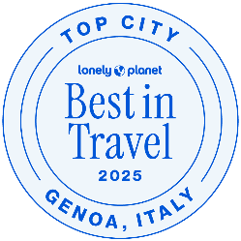

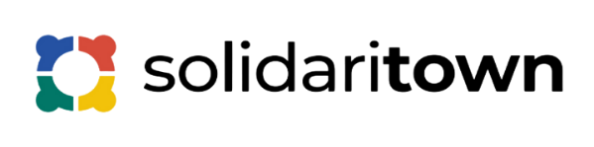

Solidaritown - Solidarity Across Towns

Citizens, Equality, Rights and Values Programme (CERV)

ITALY 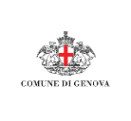

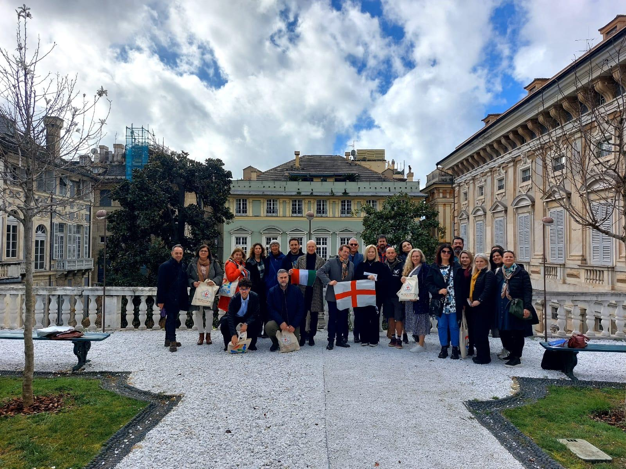6th International Event in Genova

Overview
Between March 13rd and 14th, 2025, Municipality of Genova hosted in Genova the 6th International Event in the framework of the CERV project Solidaritown – Solidarity Across Towns (titled: #WP6: SOLIDARITY FOR ACHIEVING SUSTAINABLE DEVELOPMENT GOALS).
While the main aim of the project is to explore cultural diversity, promote solidarity, and showcase the significance of Christmas traditions across the continent, this event particularly addressed the challenges faced across Europe related to sustainable development and Global goals.
Representatives from eight partner municipalities and organizations came together to witness firsthand Genova’s sustainable initiatives and the tangible impact of its solidarity for achieving Sustainable Development Goals. An international project showcased at Palazzo Tursi and on the city's tourist routes together with delegations from 7 European countries. A meeting of appreciated scientific value and a tourism proposal for the destination Genova, which involved international representatives of the partner countries through panel discussions together with important experts on cooperation (Simone D’Antonio), themes and EU funds (Marco Mazziotti, Municipality of Milan) and representatives of the Municipality of Genova (Sandra Torre-Tourism Director, Massimo Ruggero-Marketing and Tourism Department and Gianluca Saba, Head of International Department) to talk about solidarity, the tools of cooperation and topics related to Sustainable Tourism and the Urban Agenda.

Objectives
SolidariTown as a whole, as well as the WP6 event focused on six key goals:

Boost Supportive Policies: Governments should create favorable policies and legal frameworks for SSE organizations.
Education and Capacity Building: Investing in education and skills development for SSE actors is crucial.
Access to Finance: Providing tailored financial products to help SSE entities grow and scale their impact.
Research and International Collaboration: Conducting research and promoting global partnerships to support SSE principles worldwide.
Increase awareness about cultural heritage in Europe;
Better understanding about the potentialities of culture for entrepreneurship and economic development;

The event was organised as a two-day initiative, covering activities pertaining to Solidarity, Urban Agenda, Tourism, Cultural heritage and cooperative and no profit organization activities. This gathering brought together participants involved in the old town of Genova -with Palazzi dei Rolli UNESCO and Historical Shops- its historical heritage, area of urban development, such as a good practice of cultural and social renewal shared with the local community and the cooperation and volunteering partnership from all over Europe to share ideas, face common challenges and discover the potential of heritage in preparing the future of solidarity and cooperation models for development of territories and communities.
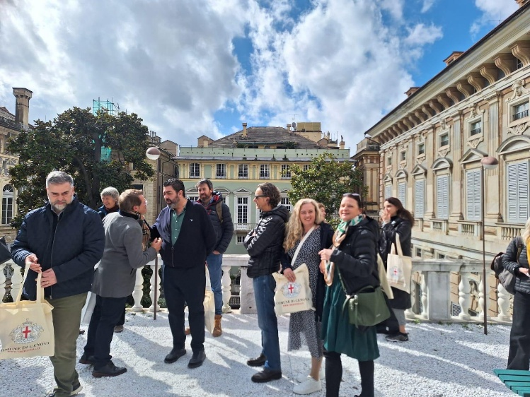
Some role-playing activities were also carried out by the international delegations among the citizens, including interviews and role-play games (“Journalist for one day” and “Critical friends”) focused on topics such as participatory democracy and shared models of solidarity, hospitality, social inclusion, accessibility, and integration. These activities aimed to be applied on a large scale across the participating countries as a small contribution from each nation towards the cause of social development—for a future that transcends Europe.
Role-playing at the Genoa meeting encouraged Open Communication because partners feel confident in sharing challenges and successes, leading to greater transparency and also Promotes Reflexivity becasue participants critically assess their own and others’ practices, identifying areas for improvement.
Builds Trust and Collaboration too: Constructive feedback strengthens relationships and mutual understanding among partners; Enhances Problem-Solving: By viewing issues from multiple perspectives, partners can develop more creative and effective solutions. Then, Supports Shared Learning: The process becomes a collective learning experience, enriching the project’s overall impact.
In the context of international collaborations focused on social inclusion, solidarity, and participatory democracy, role-playing combined with the Critical Friend approach helps partners (explore different cultural and social contexts; test and refine models of inclusion and cooperation; strengthen empathy towards marginalized groups) in particula co-create shared strategies for implementing sustainable development goals. By integrating role-playing and the Critical Friend method, partner organizations move beyond traditional meetings, creating dynamic spaces for dialogue, learning, and innovation.

Day 1- Increase social awareness about SDGs for futuring Europe. An approach for Multicultural Dialogue, Cultural Heritage and Touristic Potential

The theme of solidarity, cooperation, and European planning among different communities was the guiding thread of the WP6 meeting, which from the very first day addressed the topic of the Sustainable Development Goals with the aim of proposing the establishment of a support network for people who are victims of any form of discrimination, marginalization, and social exclusion in Europe and around the world.
In this regard, the international project presented in Genova doesn’t intend to celebrate diversity and solidarity only during specific times of the year, but rather to address the current challenges in Europe—from war and political conflicts to the increasingly widespread issues that hinder social development, such as integration, empowerment, immigration, and accessibility—while simultaneously encouraging collaboration between cities and the active participation of citizens in promoting peace, justice, and social inclusion.
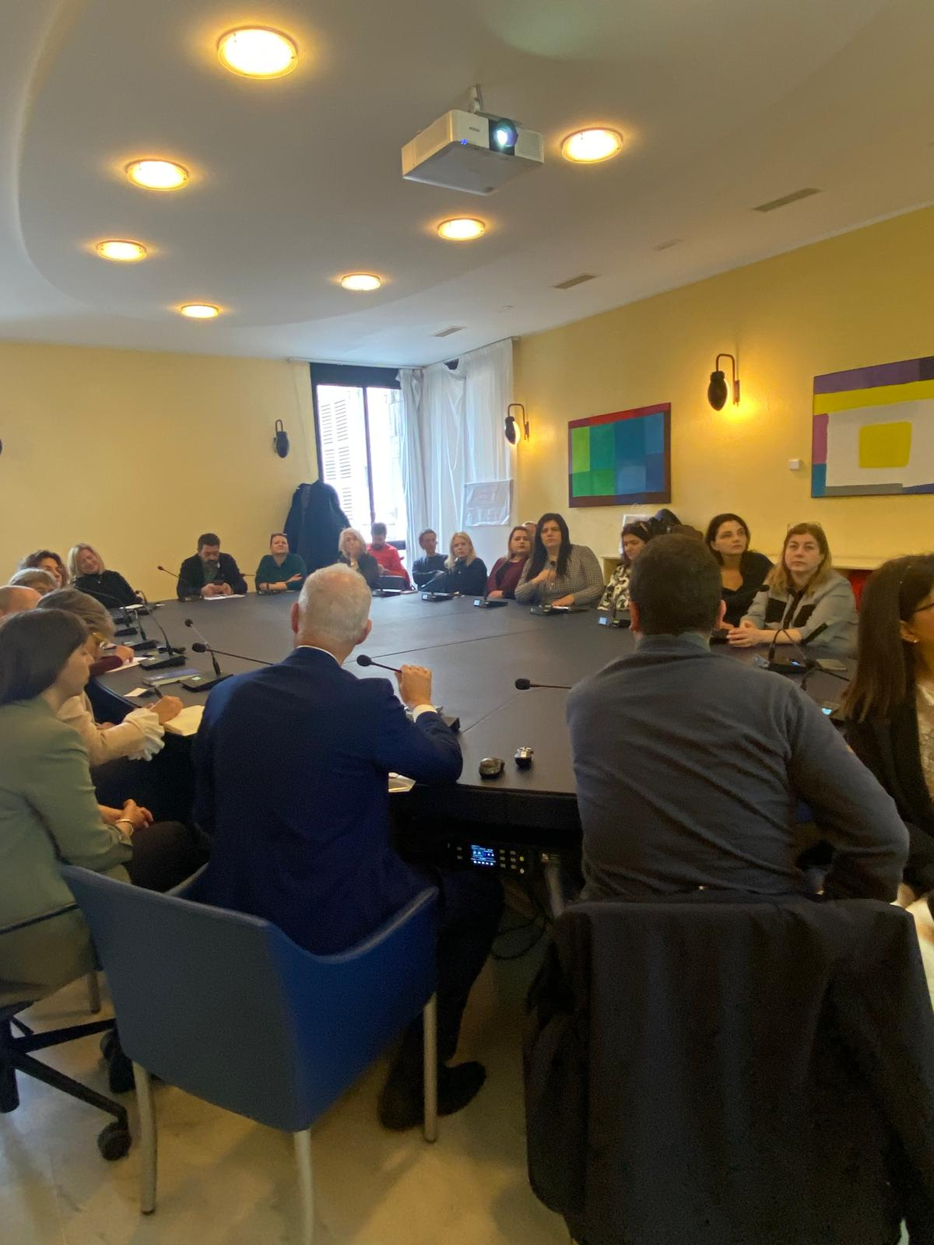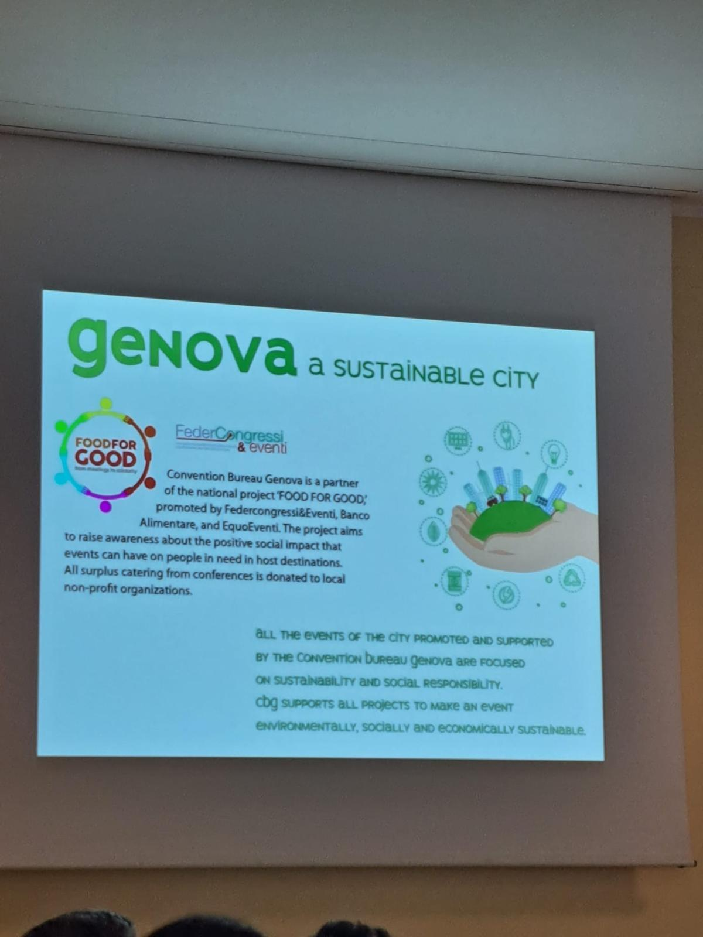

The first day of the event began with a fragment on Solidarity Dialogue, where participants exchanged ideas about how Europe’s shared cultural heritage can create new opportunities in the workfield. These discussions set the stage for an agenda-setting session, where practical next steps were proposed to promote cultural inclusion and preserve traditions in participants’ own home communities. Involving solidarity and cultural heritage in the pursuit of Sustainable Development Goals (SDGs) can be achieved through various strategies as follows:
Cultural Heritage Preservation: Protecting and promoting cultural heritage sites and traditions can contribute to SDG 11 (Sustainable Cities and Communities) and SDG 8 (Decent Work and Economic Growth) by supporting local economies and community identity.
Community Engagement: Engaging local communities in cultural heritage projects can foster solidarity, social cohesion, and a sense of belonging, aligning with SDG 16 (Peace, Justice, and Strong Institutions).
Sustainable Tourism: Promoting sustainable tourism that respects and showcases cultural heritage can support SDG 8 (Decent Work and Economic Growth) and SDG 12 (Responsible Consumption and Production) by generating income and promoting responsible travel practices.
Education and Awareness: Using cultural heritage as a tool for education and awareness-raising can promote the SDGs, particularly SDG 4 (Quality Education) and SDG 12 (Responsible Consumption and Production).
Intergenerational Knowledge Transfer: Preserving and transmitting cultural heritage to future generations can ensure the continuation of traditional practices and knowledge, supporting SDG 4 (Quality Education).

Examples of Successful Initiatives in Genova:

Community-based tourism projects: Initiatives that empower local communities to manage and benefit from tourism can promote cultural heritage and support sustainable development.
Cultural festivals and events: Festivals and events that celebrate cultural heritage foster community solidarity, promote social cohesion, and support local economies.
Heritage conservation projects: Projects that preserve and restore cultural heritage sites can promote community identity, support local economies, and contribute to sustainable development.
By leveraging solidarity and cultural heritage, communities can work together to achieve the SDGs and create a more sustainable and equitable future.
A highlight of the event was the Expert Panel, which sparked insightful dialogue with also other contributions from Vincenzo Monaco (DG of Porto Antico), Giovanni Ferrando (Board member of Convention Bureau) and Marco Bessutti (Technical Director of SeiFuori Association, Outdoor experience).
New areas of cooperation for Genoa with Slovenia (wine and food tourism-cultural itineraries), Spain, Belgium, Portugal, Poland, Romania, and Ukraine aim at developing territorial enhancement initiatives—such as rural and eco-museums for urban and metropolitan areas—and a path of scientific best practices applied to tourism and cultural heritage. This will be carried out in collaboration with the cities of Barga, Lviv, Madrid, and Valladolid, all with a focus on solidarity actions as vehicles for promoting positive values. This common thread will enable the advancement of Sustainable Development Goals for territories and local communities on a broader scale.
The day ended with a guided tour of Genova Verticale, showcasing the city’s rich cultural and historical legacy. The tour highlighted not only the beauty of Genova and its urban heritage, but also the potential of cultural tourism as a growing industry, providing good case practice examples of how to integrate tourism into the life of the city, without suffocating it with over tourism and overconsumption.

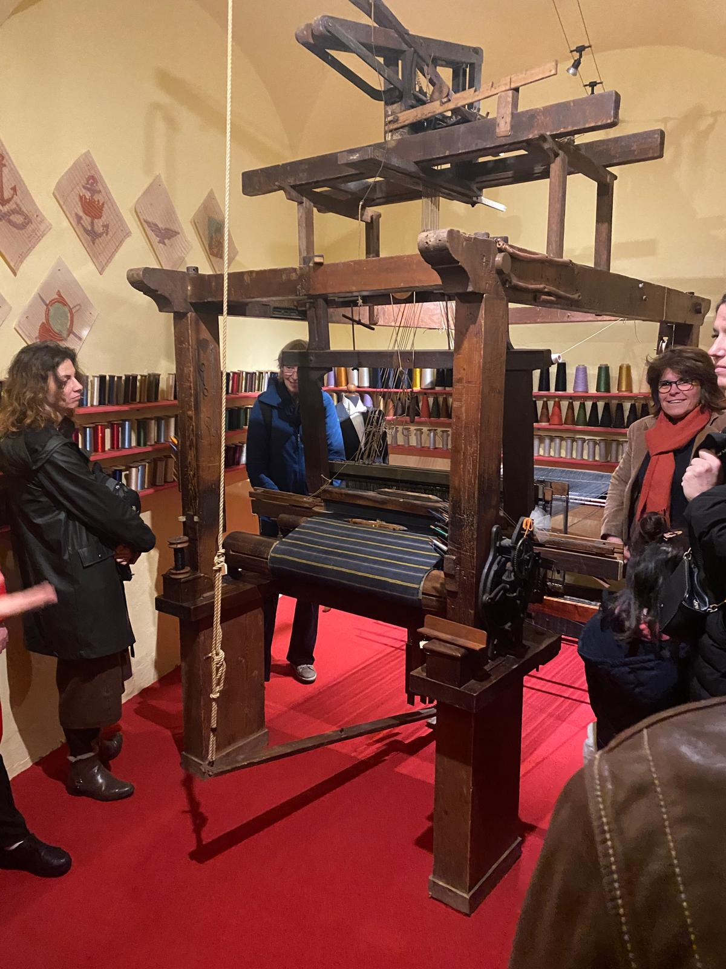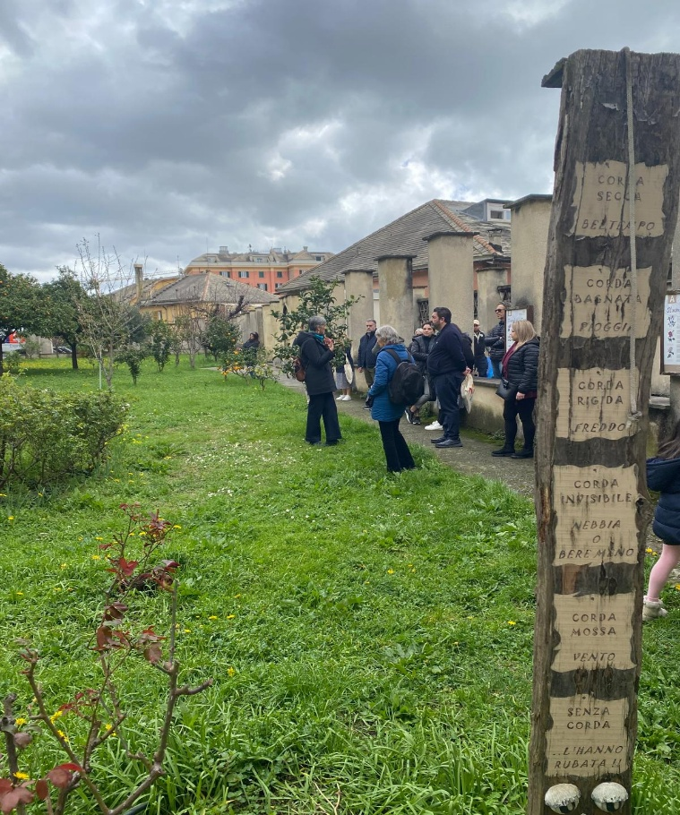
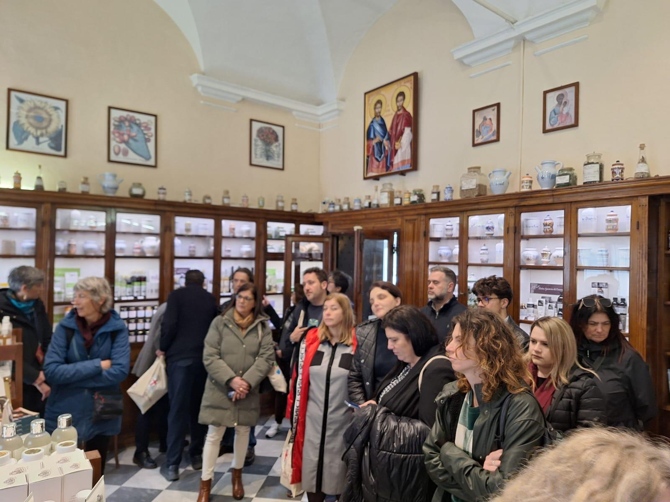

Guided tour to Hostorical Shops. Sharing Solidarity with Awareness of cultural heritage

Conclusions.

Solidarity in Genova can enhance culture and tourism in several ways.

Community-based tourism: by supporting local communities and involving them in tourism development, solidarity can promote authentic cultural experiences and ensure that benefits stay within the community.

Cultural exchange: Solidarity can facilitate cultural exchange between tourists and local communities, promoting cross-cultural understanding and appreciation.

Preservation of cultural heritage: Solidarity can support the preservation of cultural heritage sites and traditions, ensuring their protection for future generations.

Empowering local communities: By empowering local communities to take ownership of their cultural heritage and tourism development, solidarity can promote sustainable tourism practices and equitable distribution of benefits.

Responsible tourism practices: Solidarity can promote responsible tourism practices, such as fair labor standards, environmental sustainability, and respect for local customs and traditions.

Conclusions. Examples of Genoese solidarity in tourism in 5 main topics

In Genova, solidarity in tourism is not an abstract concept — it is practiced through inclusion, community empowerment, cultural respect, and social innovation. These examples show how tourism can become a tool for human dignity, participation, and sustainable development, creating benefits not only for visitors but especially for local communitiesExamples of Genoese Solidarity in Tourism

1. Inclusive Tourism for Social Integration
Genova promotes accessible and inclusive tourism experiences, especially for people with disabilities, elderly visitors, and marginalized groups. Through collaborations with local associations, museums, and tourism operators, the city has developed:
- Barrier-free routes in the historic center;
- Inclusive guided tours for people with sensory or cognitive impairments;
- Cultural workshops that actively involve immigrants and local communities.
These efforts support SDG 10 (Reduced Inequalities) and SDG 11 (Sustainable Cities and Communities).

2. Community-Led Regeneration through Eco-Museums

In several neighborhoods, Genoa supports eco-museum projects that involve residents in preserving and promoting local heritage. These initiatives are not just about tourism—they are about empowering local communities to tell their own stories, manage cultural spaces, and welcome visitors in a more authentic, sustainable way.
This is a clear example of cultural solidarity and aligns with SDG 4 (Quality Education) and SDG 8 (Decent Work and Economic Growth).

3. Solidarity-Based Hospitality Programs
Through cooperation with NGOs and local social cooperatives, Genoa has supported solidarity hospitality programs that involve:
- Employing refugees or people in vulnerable situations as cultural mediators or guides;
- Using tourism-related revenue to support community welfare projects;
- Promoting “social B&Bs” or community-run hostels that reinvest profits in social inclusion.
These models connect tourism with social justice, in line with SDG 1 (No Poverty) and SDG 16 (Peace, Justice and Strong Institutions).

4. Solidarity Events and Cultural Festivals
Events like the “Suq Festival of Cultures” in Genoa bring together dozens of communities, artists, and citizens to celebrate diversity and dialogue. These events have become important touristic attractions, while also promoting intercultural understanding and peaceful coexistence—key aspects of social solidarity.
They directly support SDG 17 (Partnerships for the Goals) and SDG 5 (Gender Equality) by giving voice to women, migrants, and minority communities.

5. Educational Tourism for Global Citizenship
Genoa is involved in EU-funded projects that promote educational tourism aimed at young people, educators, and volunteers. These initiatives link tourism with civic education, environmental sustainability, and intercultural learning, fostering a sense of shared European identity and responsibility.
This contributes to SDG 13 (Climate Action) and SDG 12 (Responsible Consumption and Production), while embedding solidarity as a value in youth-oriented travel.
Day 2- PANEL EXPERTS
Solidarity for achieving Sustainable Development Goals. Analysing projects in Genova about Sustainable Development Goals and Solidarity

Presentations of examples of European Agenda Partnerships and discussions on the potential follow-up in the EU future policies.
- Analysing projects in Genoa about Sustainable Development Goals and Solidarity.
- Peer review of partner cities with the contribution of local social cooperatives that collaborate with the Municipality of Genoa on social and solidarity issues. Contribute of Valentina Giovine (Social Coperative “Il Cesto”) and Valentine Vagge (Social Coperative Agorà).

Over the course of two days, intercultural and solidarity dialogues highlighted the importance of strengthening communities and the bonds among their members, including those in positions of power. A shared conclusion emerged: sparking a significant change in mentality is essential and at the same time, poses a lot of challenges. To reach the goals of the Sustainable Development Goals accross Solidarity and truly achieve a genuine “social transition”, citizens must play an active role at every stage of the process.
The event featured detailed presentations showcasing concrete examples of European Agenda Partnerships aligned with Genoa’s strategic priorities. These were followed by in-depth discussions on how these partnerships—grounded in social and cultural solidarity—can be further integrated and supported within future EU policy frameworks. The central theme was how solidarity acts as a crucial foundation for fostering collaboration aimed at achieving the Sustainable Development Goals (SDGs).
For Genova, solidarity is a key to addressing local challenges such as social exclusion, urban regeneration, and the integration of migrant communities. Through partnerships with cities like Barga, Lviv, Madrid, and Valladolid, Genova is developing initiatives that support:
- SDG 1: No Poverty, by creating support networks for vulnerable groups affected by economic hardship and social marginalization, such as the city’s ongoing social inclusion programs for refugees and low-income families.
- SDG 4: Quality Education, through cultural and educational itineraries promoting inclusion and intercultural dialogue, exemplified by the “European Cultural Routes” project that connects Genoa with partner cities through shared heritage and learning experiences.
- SDG 5: Gender Equality, encouraging equal participation in community projects and leadership roles, supported by local NGOs and city initiatives that promote women’s empowerment and active citizenship.
- SDG 10: Reduced Inequalities, by promoting social inclusion programs targeting immigrants and marginalized populations, including multilingual support services and community centers designed to foster integration.
- SDG 11: Sustainable Cities and Communities, focusing on eco-museum projects and urban regeneration to enhance local heritage and green spaces, such as the redevelopment of historic neighborhoods and the promotion of eco-tourism routes highlighting Genoa’s unique cultural and natural assets.
- SDG 16: Peace, Justice, and Strong Institutions, fostering citizen participation and collaboration among municipalities to strengthen social cohesion and democratic governance through initiatives like participatory budgeting and cross-border municipal cooperation platforms.
These initiatives are deeply connected to broader European cooperation activities that prioritize solidarity as a driving force to achieve the SDGs across the continent. Genova actively participates in transnational networks and EU-funded projects that promote shared responsibility and joint action among European cities and regions. This cooperation enables the exchange of best practices, capacity building, and the creation of synergies that amplify the impact of local projects.
By embedding solidarity at the heart of these partnerships, Genova contributes to a unified European effort aimed at sustainable and inclusive development. This solidarity-driven approach empowers communities, fosters cultural exchange, and strengthens social cohesion—helping to build a more just, peaceful, and sustainable Europe for all.
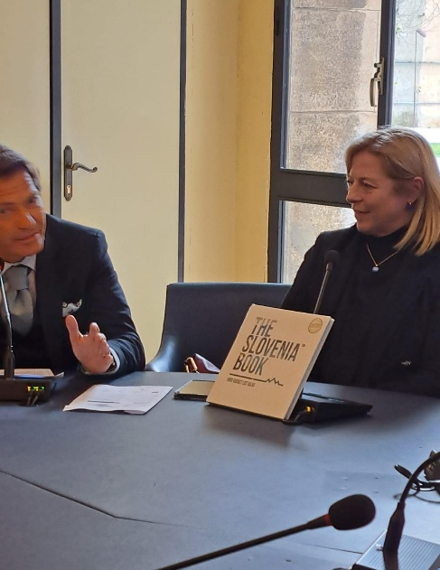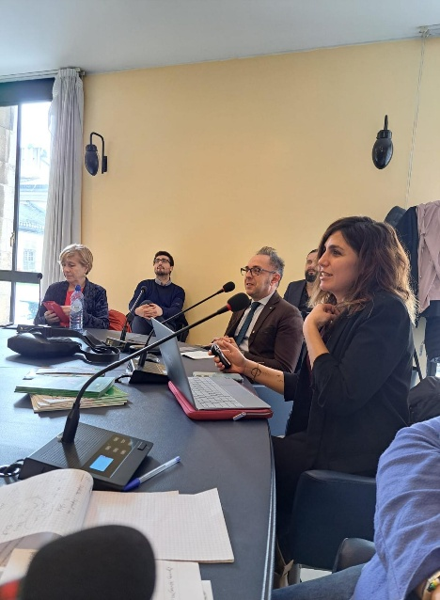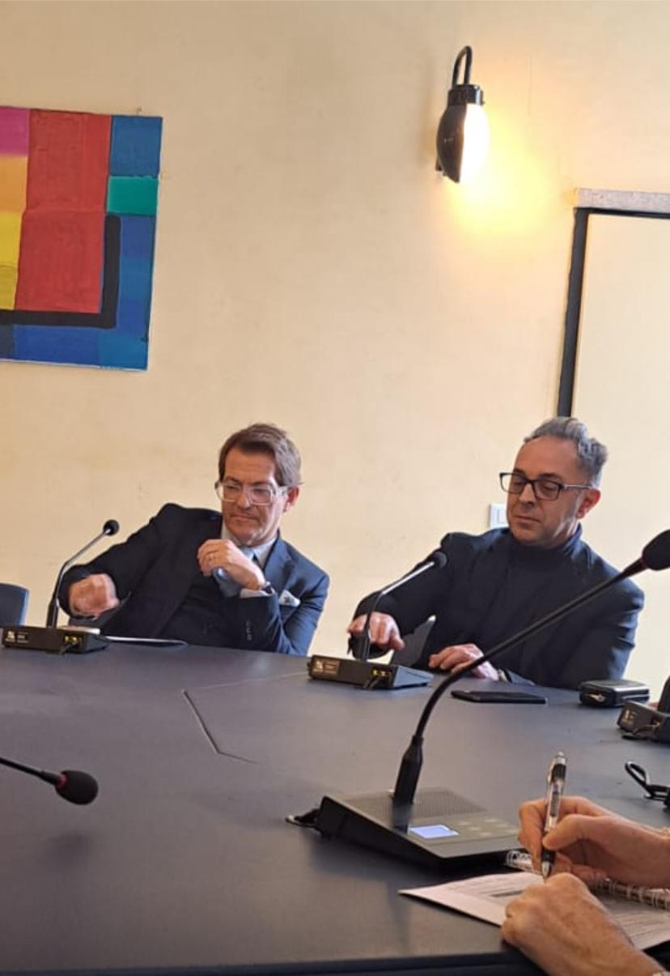
Torre Director Tourism Department Speakers for Cooperatives Vagge-Giovine Ruggero-Saba keynote speakers
Round table 3. The European framework: relations between European Agenda Partnerships and Sustainable Development Goals". Presentations of examples of European Agenda Partnerships and discussions on the potential follow-up in the EU future policies.
With project’s conclusion, WP6 Genova meeting has further enhanced our motivation to collaborate and foster a strong sense of community across European towns—maintaining solidarity as a fundamental element of our collective progress.

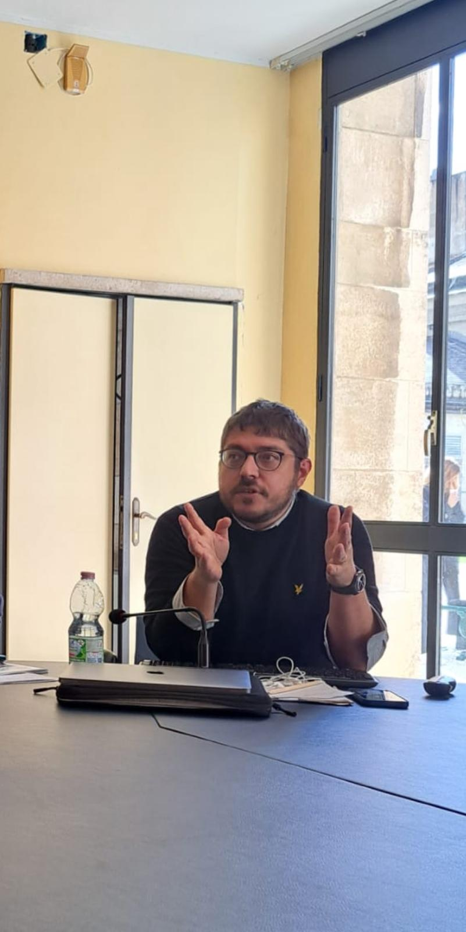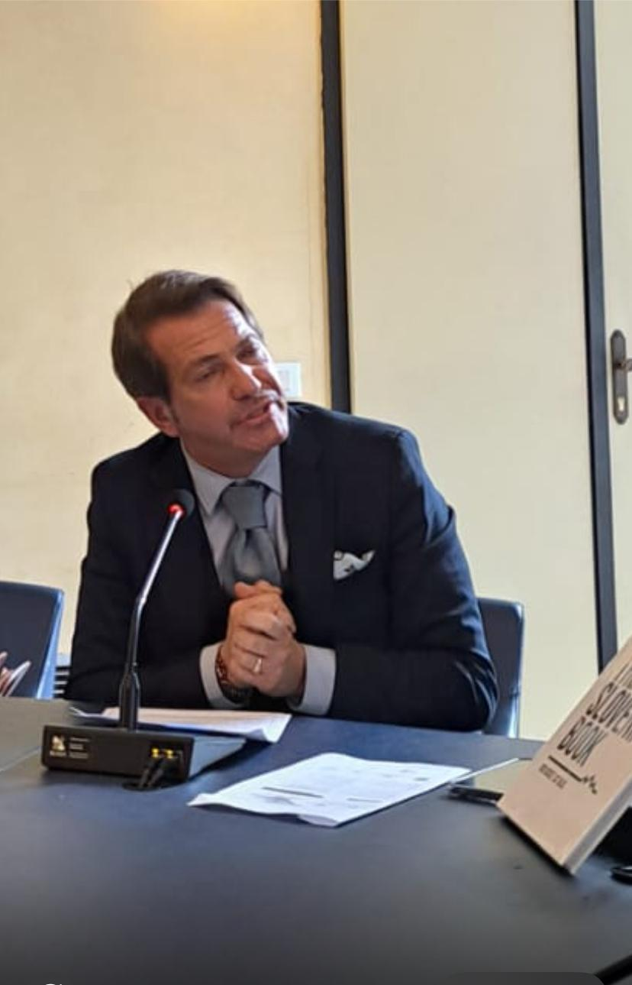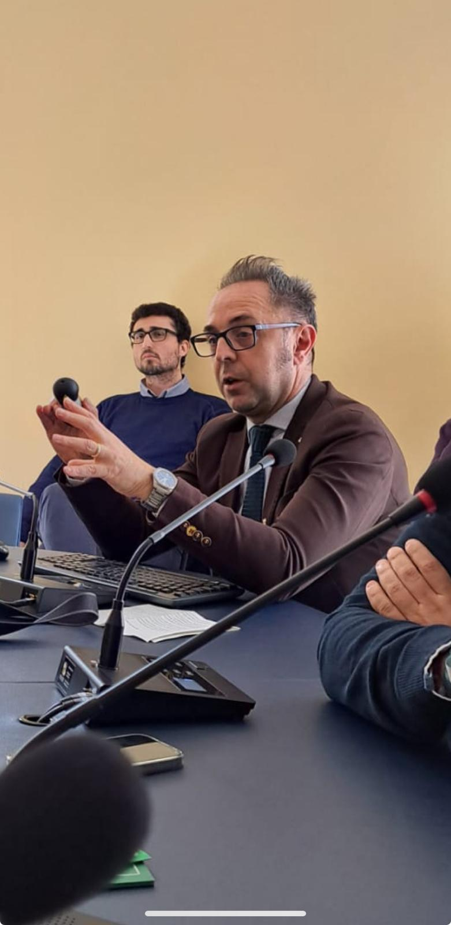
S. D’Antonio EUI lead expert M. Ruggero Tourism Marketing expert G. Saba Head of International Office
Key concepts

European Agenda Partnerships (EAPs) are collaborative frameworks established to address key challenges and opportunities across Europe, focusing on sectors such as environment, social inclusion, cultural heritage, and regional development. These partnerships bring together cities, regions, organizations, and stakeholders to coordinate efforts, share best practices, and develop joint initiatives.
The relationship between European Agenda Partnerships and the Sustainable Development Goals (SDGs) is central to ensuring that local and regional actions align with global sustainability targets. EAPs serve as practical mechanisms to implement the SDGs on the ground by fostering cooperation, innovation, and capacity building across diverse European territories.
During recent events, presentations showcased concrete examples of EAPs that have successfully contributed to advancing specific SDGs. These examples highlighted how partnerships focused on cultural heritage preservation, social cohesion, environmental sustainability, and economic development have generated positive impacts within participating communities.
Genova has been an active participant in these European collaborations, leveraging its strategic position and cultural richness to contribute meaningfully to shared goals. Key projects from Genova include eco-museum initiatives aimed at urban regeneration, cultural and food tourism routes developed in partnership with cities such as Slovenia, Spain, and Belgium, and social inclusion programs supporting marginalized groups, including migrants and refugees.
These Genova-led projects emphasize solidarity, social cohesion, and cultural exchange, directly supporting SDGs such as no poverty, quality education, reduced inequalities, sustainable cities, and peace and justice. By integrating local experiences into broader European networks, Genova fosters cross-border cooperation and knowledge sharing, enhancing the impact and sustainability of its initiatives.
Discussions also explored the potential for these partnerships, including Genoa’s projects, to be more deeply integrated into future EU policy frameworks. The goal is to enhance policy coherence, funding opportunities, and strategic support to scale up successful initiatives. Participants emphasized the importance of embedding solidarity, inclusivity, and cross-sectoral collaboration as core principles guiding this integration.
Looking ahead, the follow-up of European Agenda Partnerships in EU future policies is expected to strengthen Europe’s collective response to sustainable development challenges. By aligning EAP activities with the EU Green Deal, the European Pillar of Social Rights, and other strategic priorities, these partnerships, including Genova’s contributions, can play a pivotal role in driving the transformation towards a resilient, inclusive, and sustainable Europe.

The international mission also had the opportunity to consolidate what had been achieved in the required role-plays with further shared actions that combined the food and wine experience with the ethical and moral value of solidarity.
Cooking experiences like those at MOG in Genoa with Barbara Sanna project manager can play a significant role in fostering solidarity within network sharing projects. By promoting community building, cultural exchange, resource sharing, empowerment, social justice, sustainability, and emotional connections, these experiences can help create a more cohesive and supportive network. This, in turn, can lead to more effective collaboration and a stronger collective impact on the community.

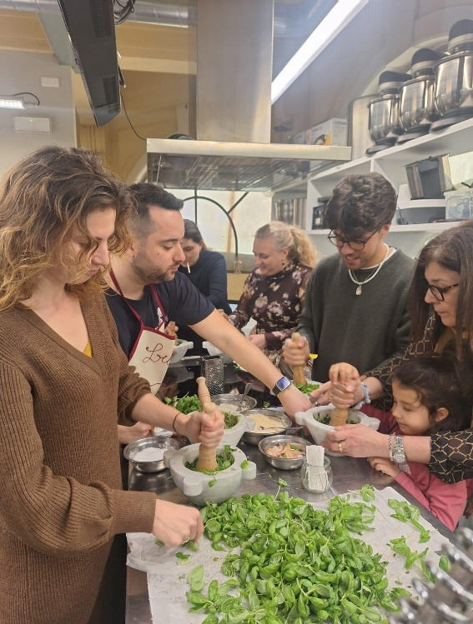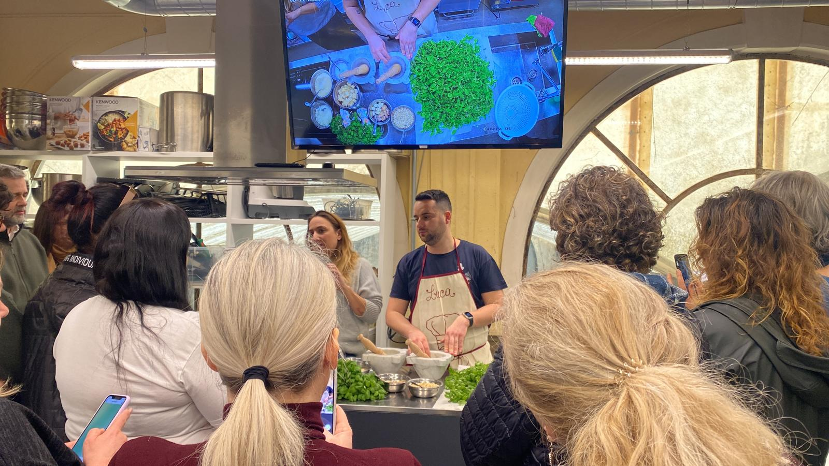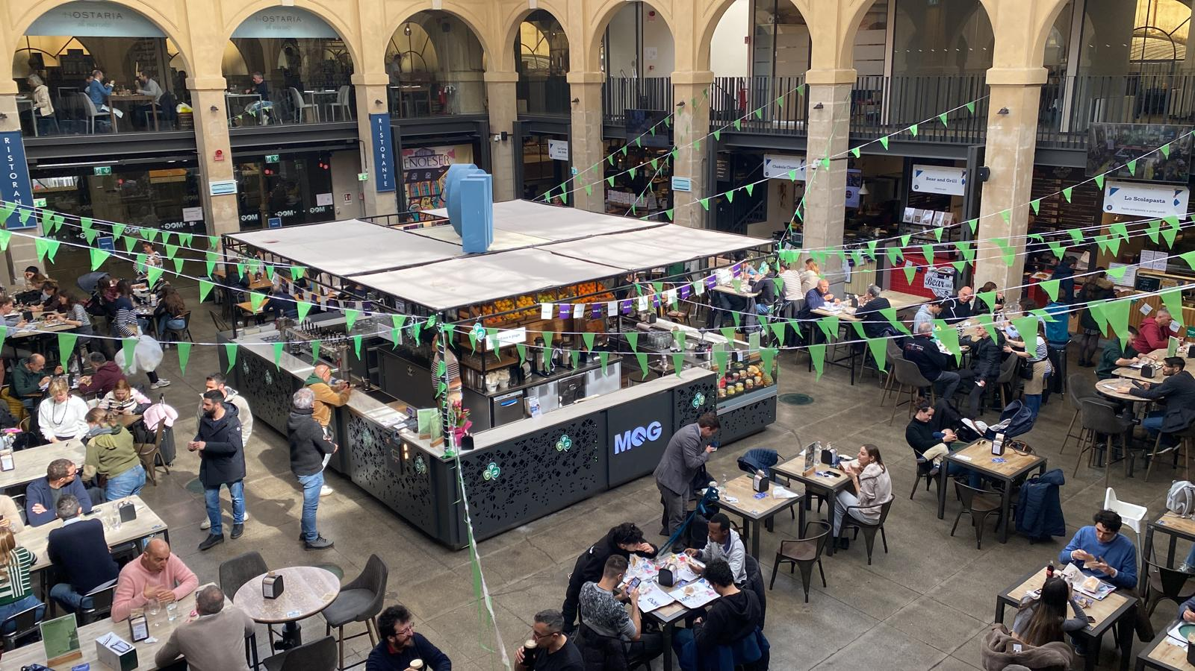
Leisure Pesto Experience, cooking show for Genova Solidarity in network sharing projects.
The last day concluded with a guided tour of Genova’s Old Town, showcasing the city’s rich cultural and historical heritage. It was a journey through the knowledge of the world-renowned heritage of its historic Rolli Palaces and numerous cultural landmarks that make Genoa one of the most historically, culturally, and architecturally attractive cities.

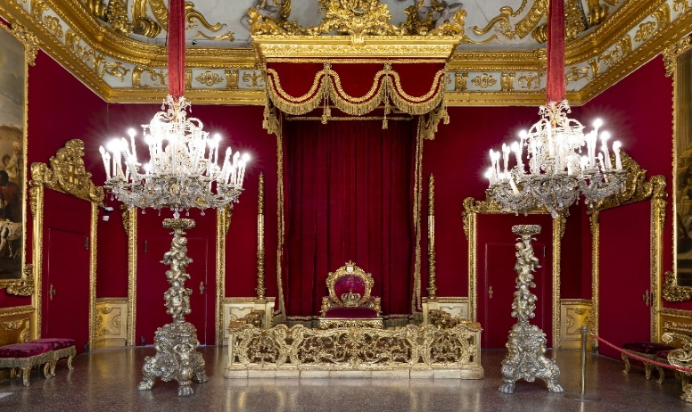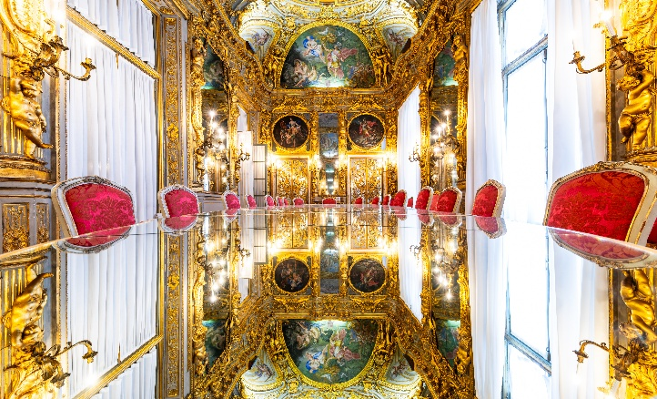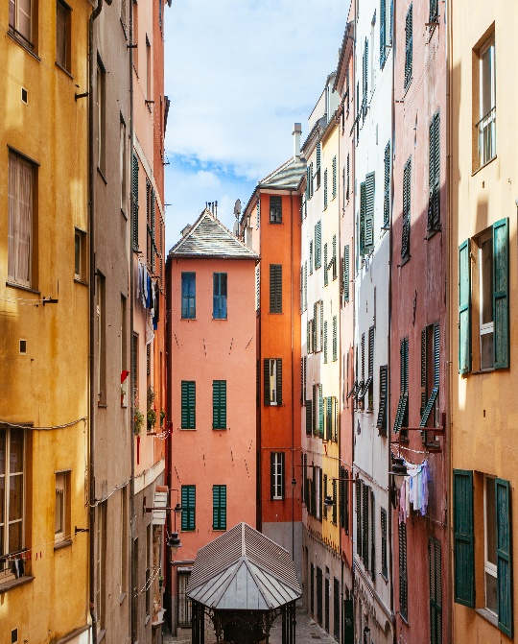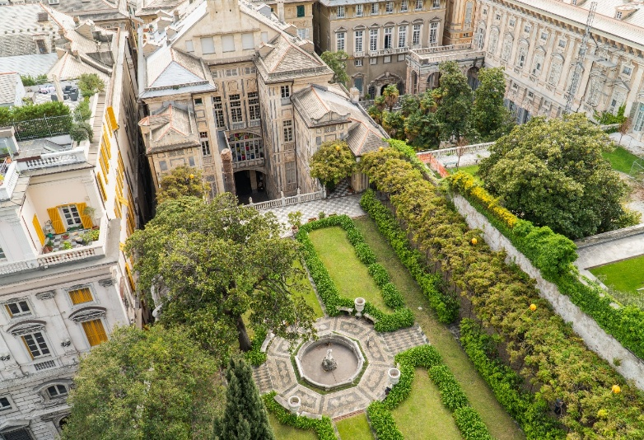
Palazzi dei Rolli, UNESCO World Heritage list by Ennio Poleggi and Genova Old Town overwiew
How you can involve Solidarity in a concrete strategy? By bringing together participants from different backgrounds, the tour served as a living example of social and cultural solidarity, fostering mutual understanding and respect. It demonstrated how solidarity can strengthen community ties and support inclusive cultural exchange, essential elements for promoting peace, cohesion, and sustainable development within Genova and across Europe.
Conclusions. To promote history and boost awareness of Genova's tradition while involving solidarity, consider the following:
Community-led tours: Collaborate with local guides and communities to create authentic, immersive experiences that showcase the city's history and culture.
Cultural exchange programs: Develop programs that bring together locals, tourists, and international partners to share knowledge, traditions, and perspectives.
Restoration projects: Engage local communities and organizations in restoration efforts, promoting a sense of ownership and responsibility for preserving Genova's heritage.
Inclusive storytelling: Share diverse narratives and histories, highlighting the experiences of various communities and social groups that have shaped the city's identity.
Promoting History and Awareness to effectively promote Genova's history and boost awareness of its tradition, consider:
Guided tours: Offer themed tours, such as historical walks, art tours, or culinary experiences, that highlight the city's unique heritage.
Cultural events: Organize festivals, exhibitions, and performances that celebrate Genova's history, art, and traditions.
Education and outreach: Develop programs for schools, universities, and local communities to educate them about Genova's history and cultural significance.
Digital platforms: Utilize digital platforms, such as interactive maps, virtual tours, and social media, to showcase Genova's heritage and reach a wider audience.
SolidariTown was made possible through the grants provided by the European Commission, and is a direct outcome of the joint efforts of the founding partners:
- Christmas Cities Network, Spain
- Medina de Rioseco Townhall, Spain
- Comune di Genova, Italy
- EducPro, Portugal
- Fundacja Autokreacja, Poland
- Center for Entrepreneurship and Tourism Krško, Slovenia
- Lviv Polytechnic National University, Ukraine
- Asociatia Se Poate, Romania

- EVENT DESCRIPTION SHEET WP6_SOLIDARITOWN .docx Download



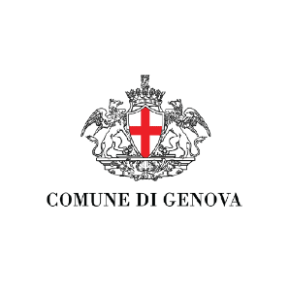

Partners
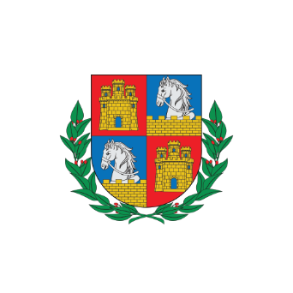

Municipality of Medina de Rioseco


Christmas Cities Network
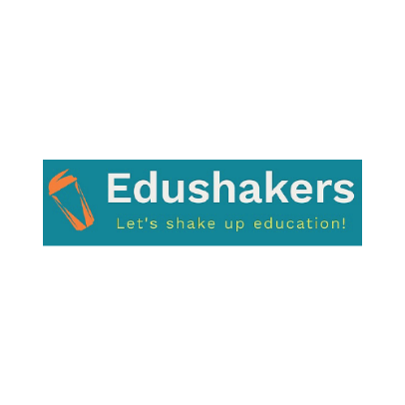

Edushakers
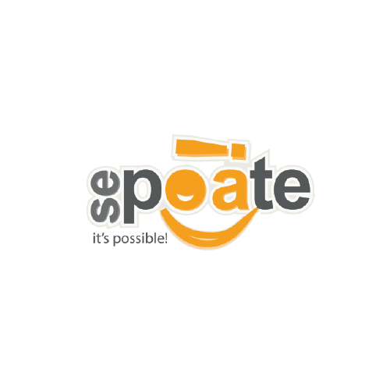

Asociatia Se Poate
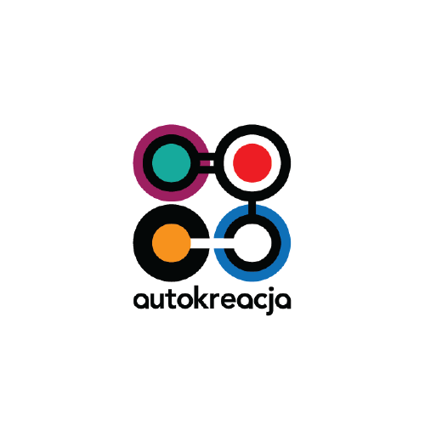

Autokreacja
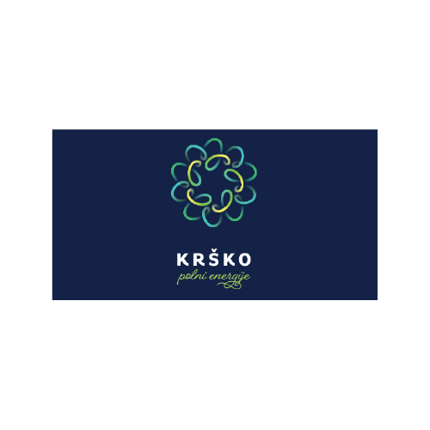

Center for Entrepreneurship and Tourism Krško
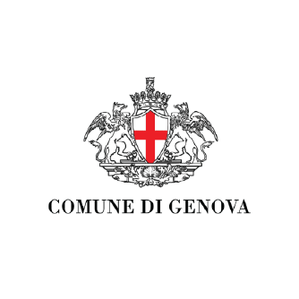

Municipality of Genoa
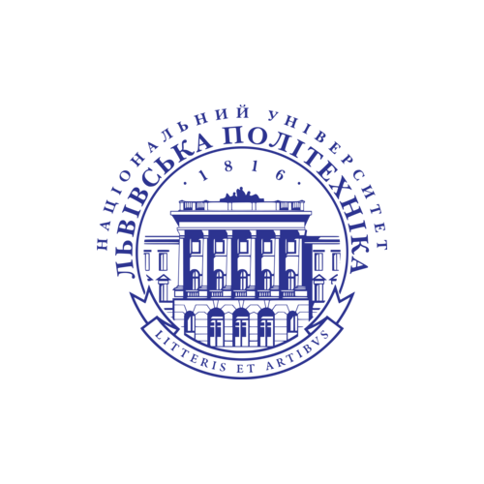

Lviv Polytechnic National University

